Consumer Health Data Aggregator Challenge submission

**Phase 1 Participation Requirements**

Swellbox

Mockup/wireframes of the app

(see app screenshots of fictional account)

* + 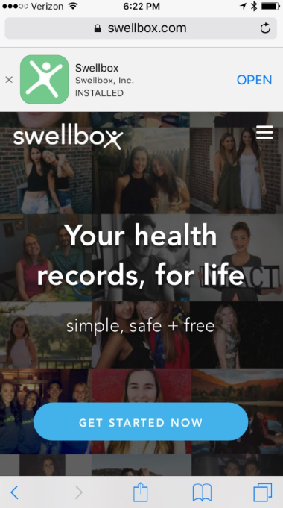 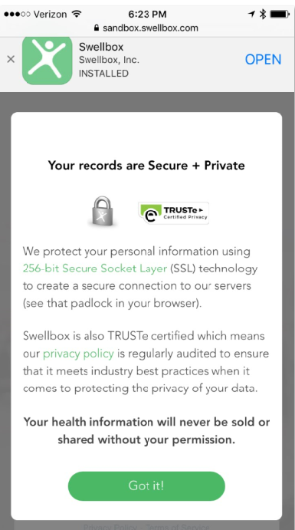

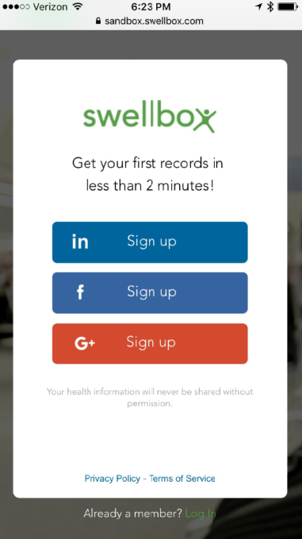 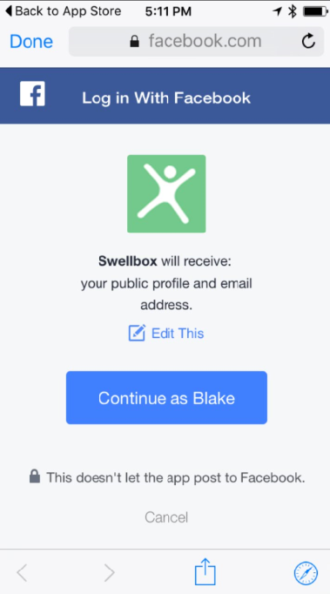

* 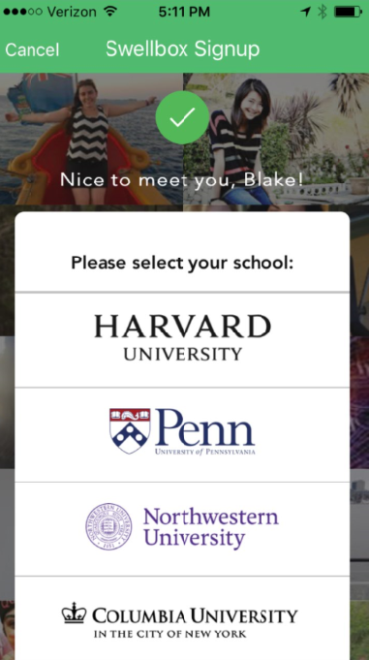  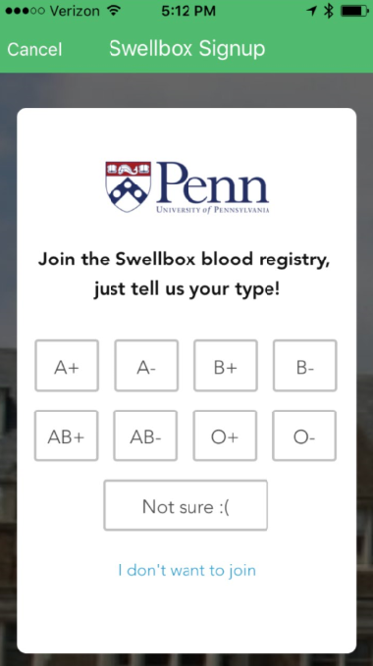

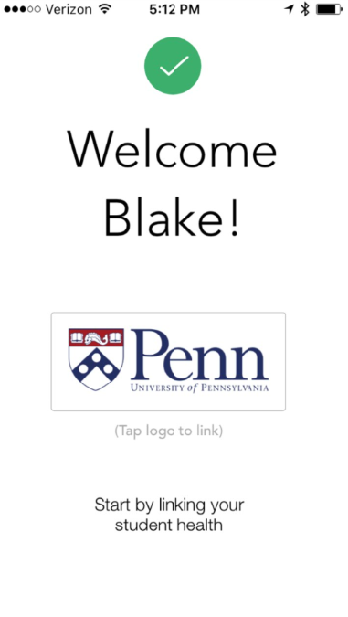 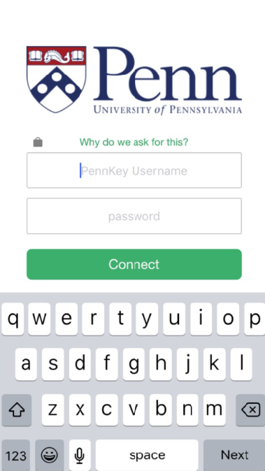

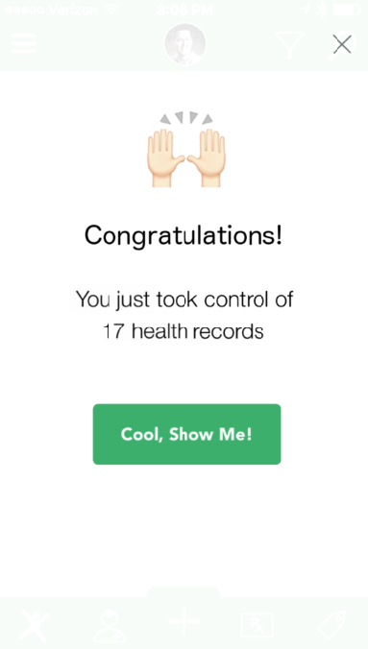 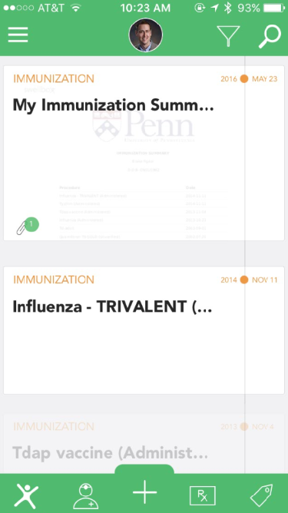

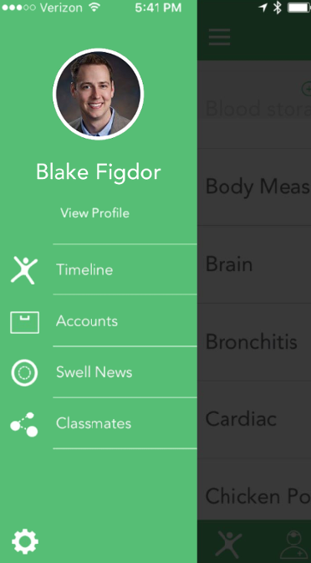 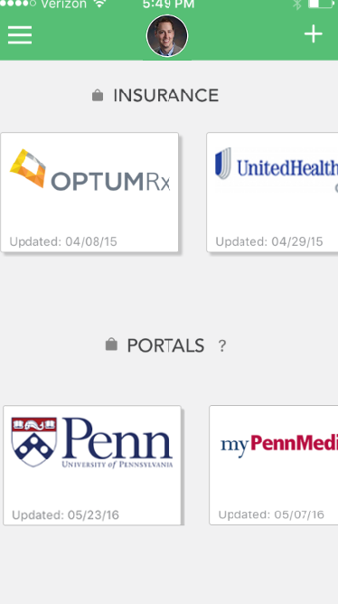

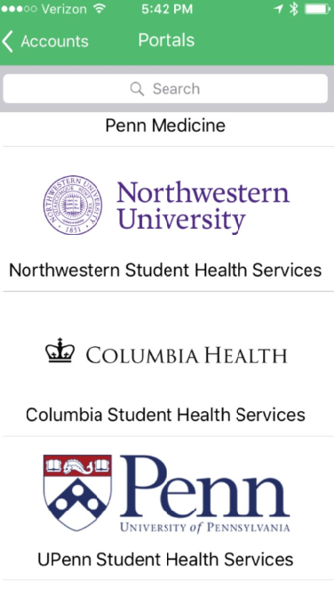 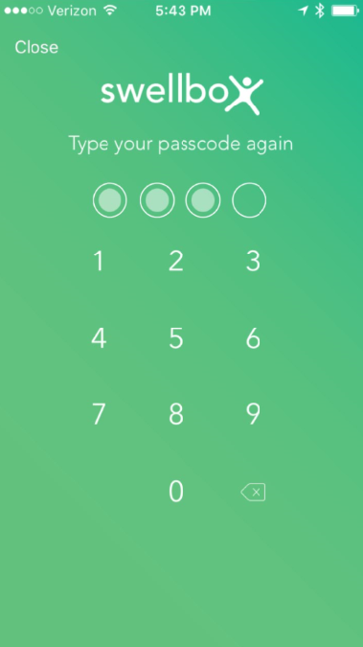

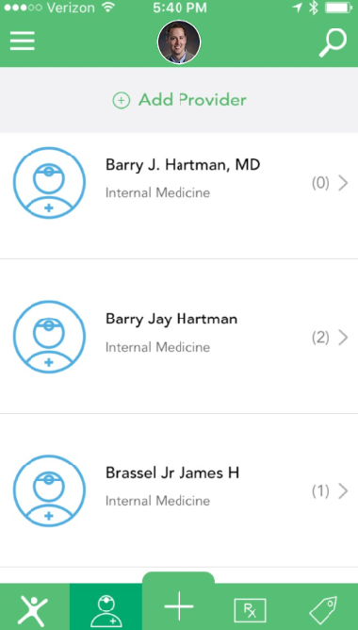 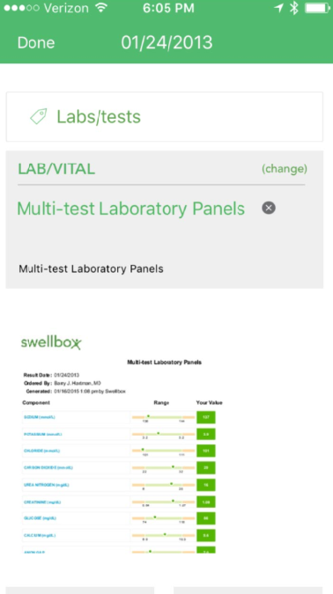

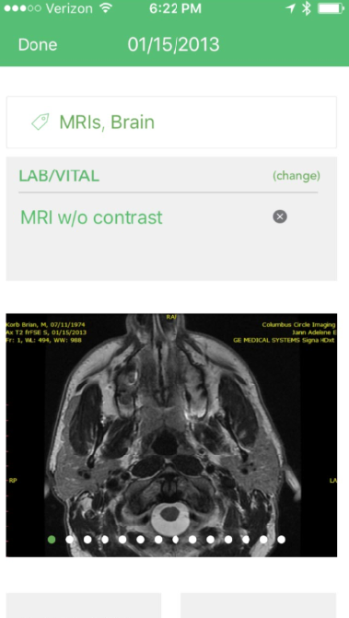 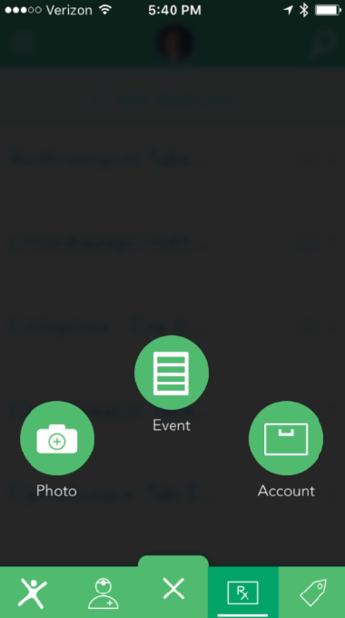

Technical Specifications

Our planned data sources include, but are not limited to:

1. Penn Medicine (Epic) – [https://secure.mypennmedicine.org](https://secure.mypennmedicine.org/)
2. Partners HealthCare – <https://patientgateway.partners.org/public/>

(which is also currently undergoing an Epic conversion, and is a founding organization of Project Argonaut <http://argonautwiki.hl7.org/images/4/4e/Argonaut_Implementation_Program_Phase_2_-_23_Jul_2015-v2.pdf>)

1. Harvard University Health Services (Point-N-Click)- <https://patient.uhs.harvard.edu>
2. University of Pennsylvania Student Health Services (Point-N-Click) – [https://shs.upenn.edu](https://shs.upenn.edu/)

The privacy and security of the integrations with these health systems will heavily rely on industry best practices (encryption of sensitive data in transit and at rest) as well as our publicly accessible comprehensive privacy policy available through our website – <https://www.swellbox.com/company/privacy>. While we currently integrate with these health systems through the use of other means for piloting and proof-of-concept purposes, our ultimate goal is to drive adoption of FHIR in production settings at these institutions.

Students who are patients at the health systems outlined above will have the ability to opt-in to downloading their health records with Swellbox by registering an account. Opting in to downloading their records has many advantages and is considered a best practice because it increases consumer confidence and control. One advantage is that it helps to alleviate undue burdens on health systems who remain concerned to interoperate because of their responsibility in the event of data breaches due to HIPAA guidelines. By Students opting in, they are made aware upfront (prior to registration) of our privacy and security practices and are aware of any risks arising from the use of the service. We believe this opt-in helps to alleviate a top concern for health systems wishing to interoperate in production settings.

While Swellbox would not be considered a covered entity under HIPAA (due in part to student/patient opt-in), we adhere to our own internal set of privacy and security guidelines (which are publicly accessible) and are certified by TRUSTe (<https://privacy.truste.com/privacy-seal/validation?rid=91358767-8c4e-4827-9b9b-cd6282d4ea41>) which regularly audits and verifies our privacy practices.

Technical Specifications (continued)

Technical Solution Data Flow Chart:

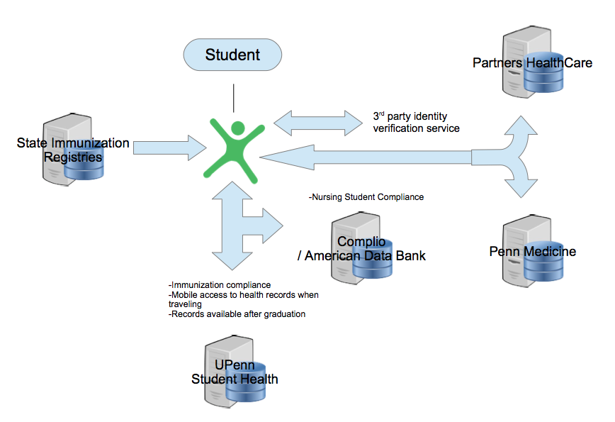

**Business/Sustainability Plan**

Issue Analysis

We propose to enter colleges/universities where the Administrators as well as Students have unique pain points related to access, control and transmission of electronic health records:

1. **Student Health Administrators** (2,968 4-year colleges in the US):
   1. Need to acquire proof of immunizations and other health background to enroll students which is currently very manual process (i.e. colleges hiring several temp workers in the summer to get immunizations into their system)
   2. Need to frequently coordinate with students’ external physicians to provide best care
   3. Schools receive frequent record requests from students after they graduate (e.g. to attend grad school, to show a new provider etc.) and is currently a laborious process to fulfill those requests.
   4. Nursing and Med Schools need to manage clinical compliance for their students and currently have disparate systems that are inefficiently connected and leads to a lot of missed deadlines and related hassles.
2. **College Students** (13,300,000 total enrolled 4-year colleges in the US):
   1. Need to submit immunization proof and other health background to matriculate
   2. Transition in and out of the school health system during their time at college (e.g. going home of the Summer, going abroad or other travel
   3. Students graduate and leave the health system and in many cases quickly get cut off from access to their health data for when they arrive in their new location
   4. Students may utilize emergency services at local hospital that needs to interact with student health but there’s no direct link
   5. Med school and Nursing students at select universities need to manage clinical compliance to work in health systems which is not efficient

Solution Description

Providing an app for Students and Colleges to seamlessly manage and transmit important health data and having it all in one place, owned and controlled by Student.

**How it addresses the issues:**

* Create a secure link to student health systems to import data (e.g. immunization compliance to matriculate) as well as export data (all their immunizations, encounters, medications, labs, etc.) for students to have with them after graduating as well during school when off campus and/or visiting another provider.
* For immunization compliance specifically connect a direct link to State immunization registries- integrate with third party identity verification services (e.g. Experian) to confirm identities
* Create additional links to providers and hospitals in the vicinity of the college where several students are likely to have additional data and need for sharing.
* Strong usability (UX) and design (UI)- Most college students are very digital and mobile savvy and have a high standard for usability. Create a clean, simple, efficient app that is very “familiar” to this demographic (i.e. similar look and feel to Uber, Dropbox, Venmo, Mint, etc.)
* For Nursing and Med students’ clinical compliance, create a seamless integration with the third party software applications currently used for this function (e.g. American Data Bank, Complio, etc.)

Financial Estimates

***See attached spreadsheet***

Engagement Plan

Engage with senior student health administrators and drive grass roots awareness and interest at the student level

Engagement we’re already doing with targeted customers:

1. **Student Health Administrators**
   1. Met with senior student health administrators at 3 top-tier colleges (UPenn, Harvard and Stanford)
   2. Discussed their pain points with current immunization compliance process
   3. Discussed their desire for students to be “better consumers of their health”
   4. Reviewed pain points related to difficulties sharing information with student’s off campus doctors (as well as medical incidents for students studying abroad)
   5. Gave demo of our app showing improved interface with greater transparency and efficiency.
   6. Got buy-in that our app makes sense and what the future should be
   7. Already led to changes at UPenn making students more aware about the importance of getting their medical records (see below)

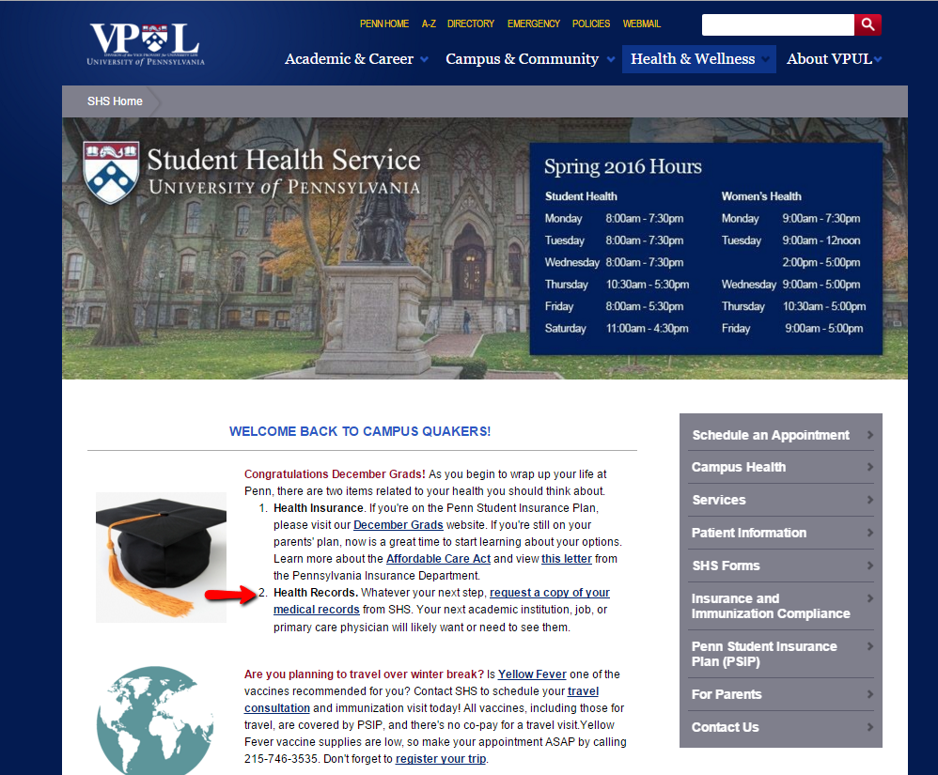

Engagement Plan (continued)

1. **College Students**
   1. Engaged with key campus organizations to introduce Swellbox and get their support- student government, healthcare clubs, etc.
   2. Recruited over 10 unpaid Ambassadors across 3 colleges to promote Swellbox across campus (both undergrad and graduate populations)
   3. Ambassadors ran campaigns (Facebook, email, live events, etc.) leading to several hundred student signups
   4. As a result, student govt at UPenn passed a resolution to improve student access to health records
   5. Student newspaper at UPenn ran a story about student activism for better health record access and highlighted Swellbox’s involvement (see below)

<http://www.thedp.com/article/2016/04/shs-health-records-swellbox>



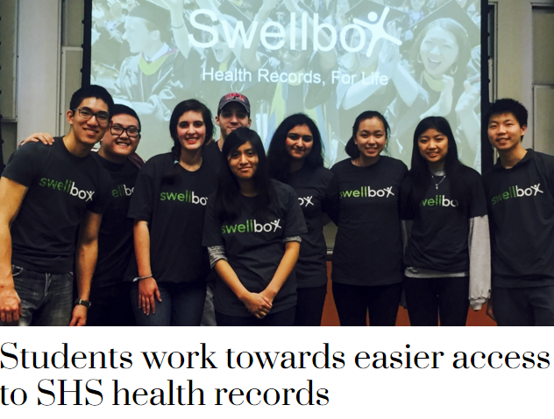



Provider Partnership

We’ve already done pilot testing (not currently via FHIR) at schools where we have 1,000+ student signups. Schools are aware of our product and student involvement (currently students can sign up without needing the school’s permission).

We continue to progress toward more formal implementation with the colleges ideally incorporating FHIR API

